

## SSR COLLEGE OF ARTS, COMMERCE & SCIENCE SILVASSA

**(Affiliated to Savitribai Phule Pune University, NAAC Accredited with B+ Grade)**

**Submitted to the partial fulfillment of**

S.Y BBA(CA)

### 2021-2022

Project Work

“QUIZ HUB”

# Guided By: Submitted By:

2. BIPUL BERA

1. AMAN GUPTA

MR. VISHAL LANGALIYA



## SSR COLLEGE OF ARTS, COMMERCE & SCIENCE SILVASSA

**(Affiliated to Savitribai Phule Pune University, NAAC Accredited with B+ Grade)**

**Sayli, Silvassa-396230, D&N.H**

Department of Computer Application

**CERTIFICATE**

This is to certify that Mr. **AMAN KUMAR GUPTA &** Mr.  **BIPUL**

**BERA** of S.Y.B.B.A [Computer Application] has successfully completed

his project work on the topic **QUIZ HUB** in the academic year 2021-

2022.

**Project Guide** **H.O.D**

**Seal of the College**

**Internal Examiner External Examiner**

**ACKNOWLEDGEMENT**

It is a great pleasure to acknowledge and express our deep sense of gratitude to **SSR College of ARTS COMMERCE & SCIENCE** for giving an opportunity to such project.

I extremely grateful and remain indebted to our guide **Mr VISHAL LANGALIYA** for being a source of inspiration and for his constant support in the Design, Implementation and Evaluation of the project. I am thankful to him, for his constant constructive criticism and valuable suggestions, which benefited us a lot while developing the project on **QUIZ HUB**. He has been a constant source of inspiration and motivation which helped us to complete this project successfully.

I would like to thank Savitribai Phule Pune University for providing us an opportunity to apply our knowledge and skills in a practical environment as a part of curriculum for **S.Y.B.B.A [Computer Application].**

Lastly but significantly, we express sincere gratitude to all our friends and fellow students at SSR College for their help and timely advice on various occasions during this project.

**Project Members:**

**AMAN KUMAR GUPTA**

**BIPUL BERA**

**ABSTRACT**

The project titled **“QUIZ HUB”** is designed with IDE-Visual STUDIO (HTML, CSS, JAVASCRIPT, PHP) as front end and XAMPP as back end.

The quiz are designed on topics of programming language like html, php, cpp, networking.Here to access resources learner need to first register himself and then login to give quiz. Registration, quiz scores, feedbacks will be maintained in database.

This system is implemented to enhance to knowledge of learner in programming field. The Webpages are made in userfriendly interface to grab the screen quickly. The system is totally built at users end(client side).

This project report documents the process of designing and developing a webpages to be used in e-learning. The design form and the data report screenshots, advantages and limitations data dictionary, and future enhancement have been included.

**INDEX**

|  |  |  |
| --- | --- | --- |
| **S.NO.** | **TOPIC** | **PAGE.NO** |
| 1 | **INTRODUCTION**  1.Introduction to System 2.Scope Of The System | 6-8 |
| 2 | **TOOL INFORMATION**   1. Front End Tool 2. Back End Tool | 9-11 |
| 3 | **ANALYSIS**   1. Feasibility Study | 12-13 |
| 4 | **SOFTWARE AND HARDWARE REQUIREMENT** | 14-15 |
| 5 | **SYSTEM DESIGN**   1. DFD 2. USE CASE DIAGRAM 3. DATA DICTIONARY | 16-22 |
| 6 | **INPUT AND OUPUT DESIGN**  1.Screenshots | 23-32 |
| 7 | **REPORTS** | 33-37 |
| 8 | **ADVANTAGES AND LIMITATIONS** | 38-39 |
| 9 | **FUTURE ENHANCEMENT** | 40-41 |
| 10 | **BIBLIOGRAPHY** | 42-43 |

**1. INTRODUCTION**

**1.1 INTRODUCTION TO SYSTEM**

“QUIZ HUB” is a desktop application. This system is developed to enhance e-learning. Through this system a learner could track his/her knowledge, progress and do a proper assessment. Before moving into the new section, these also allow you to know the correct and wrong answers enabling you to grasp some new knowledge.

E-quizzes encourage students to engage and learn creatively. Students ask questions, search new topics, engage, fail, pass, and do everything that makes them understand. Learning becomes interesting even more when students participate in quizzes. The webpages is designed on interactive Multiple choice Question's on different categorized topics of programming languages. The topics are well designed as subjects topic in user profile page.

In profile page a user can see his results on past attempts, can attempt it again, also leave a feedback, lastly logout from the session.

After successful login the user comes to profile page where he can opt to his desired quiz. The project has been developed to promote smart learning and way to paperless society which is far better then pen and paper tests which involves a huge usage of papers.

The user can access the every visible links on the pages as it is client side.

**1.2 SCOPE OF THE SYSTEM**

The program deals with creating a e-learning environment which will increase the knowledge of students by attempting the quiz

Scopes that have been considered during the development of the project are as follows:

1. User Friendly
2. Menu Driven Interface
3. Easily Upgradable
4. Data Retrieval, Updating, Insertion
5. System Consistency
6. Allowing Keyboard Inputs
7. Taking care of Computing time
8. Easy Database Handling

**2. TOOL INFORMATION**

**2.1 FRONT END TOOL**

**MICROSOFT VISUAL STUDIO**

It is an Intergrated Development Environment from Microsoft. It is used to develop computer programs, as well as websites, web apps, web services, and mobile apps. It supports 36 different programming languages. The most basic edition of Visual Studio, the Community edition, is available free of charge. Under which we wrote html, css, php pages.

Visual Studio includes a code editor supporting IntelliSense(the code completion component).

It makes it very easy to get the user interface portion of your application up and running. It provides a fast way to work under web development.

To develop any system with the back-end tools which provide access to the database and also solves the database queries, to make system interactive with the user, the use of front end tools comes into the picture. The front-end tools make the user interface with the system easier and also provide a user-friendly environment to the system.

**2.2 BACK END TOOL**

**XAMPP**

XAMPP is a free and open-source cross-platform web server solution stack package developed by Apache Friends, consisting mainly of the Apache HTTP Server, MariaDB database, and interpreters for scripts written in the PHP and Perl programming languages.

It has got the following advantages:

* Define a database
* Query the database
* Add, update and delete the data
* Modify the structure of the database
* Secure data from public access.
* Communicate within network
* Export and import data

SQL is a structured query language that we use to communicate with XAMPP server.

**3 .ANALYSIS**

**3.1 FEASIBILITY STUDY**

The objective of the feasibility study is to solve the problem and to acquire the ease of its scope. Feasibility means practicable. The feasibility analysis focuses on the fact that whether the project will be acceptable or not. If the feasibility analysis confirms that the project is feasible, it can be taken up for development. In preliminary investigation we found that project feasible.

**Types of Feasibility:**

**a. Operational Feasibility**

Operational feasiblility makes a mark on whether the project can be done with full requirements that the clients provide or not. Includes following:

1. Analysing all requirements.

2. Can be done in given period of time or not.

**b. Technical Feasibility**

Technical feasibility takes into account the technical aspect of the project includes the following:

1. Whether the project can be implemented with the existing technology or not.

2. Whether the project technically compatible or not.

**c. Economical Feasibility**

It determines whether the requirement software is capable of generating financial gains for an organization. It involves the cost incurred on the software development team estimated cost of hardware and cost of performing feasibility study and so on.

Studying the feasibility of the project, the project can be implemented with the given period of time and with the existing or specified technology. Hence, we can conclude that this project is feasible.

**4. SOFTWARE AND**

**HARDWARE**

**REQUIREMENTS**

**4.1 SOFTWARE REQUIREMENT**

Software used in the designing (code) of the system:

Operating system: Windows 2010

Application Softwares:

* Microsoft Visual Studio [Front-End Tool]
* XAMPP [Back-End Tool]

**4.2 HARDWARE REQUIREMENT**

To run the application software of the system in the computer, the minimum hardware configuration required is as below:

* 1.7 GHz Pentium processor or other compatible
* Intel chipset motherboard
* 4 GB DDR-RAM
* Color Monitor or LCD
* Keyboard
* Mouse
* Printer

**5. SYSTEM DESIGN**

**5.1 DATA FLOW DIAGRAM**

The data flow diagram are pictorial or graphical representation of the system study. The data flow covers all the processes and data storage area, which takes place during any transaction in the system. The data flow diagrams are functionally into context level, zero level diagrams.

a. **Process:** Here flow of data is transformed

b. **External Entity:** A source or destination of data, which is external to the system.

c. **A Data Flow:** It is a packet of data. It may be in the form of document, letter, etc.

d. **Data storage:** Any storage of data but with no reference to physical memory of

storing.

**ZERO LEVEL DATA FLOW DIAGRAM**

**USER**

**enroll**

**result**

**QUIZ HUB**

**FIRST LEVEL DATA FLOW DIAGRAM**

USER

1.0

AUTHENTICATION

register

USER

NEW USER

2.0

USER

PROFILE

RESULT

SHOW

RESULT

2.2

ATTEMPT QUIZ

2.1

FEEDBACK

feedback

result

2.3

RESULT

result

3.0

LOGOUT

**5.2 USE CASE DIAGRAM**

A use case diagram is a graphical depiction of a user’s possible interactions with a system. A use case diagram shows various use cases and different types of users the system has and will often be accompanied by other types of diagrams as well.

The use cases are represented by either circles or ellipses. It specify the expected behavior and not the exact method of making it happen.

A use case diagram is usually simple. It does not show the detail of the use cases:

* It only summarizes some of the relationships between use cases, actors, and systems.
* It does not show the order in which steps are performed to achieve the goals of each use case.

ADMIN

USER

**5.3 DATA DICTIONARY**

Data dictionary is a repository that contains description of all the data objects consumed By the software. It is a list of names used by the system alphabetically. As well as the name, the dictionary should include a description of the named entity and, If the name represents of a composite object, there may be description of the name entity. Other information such as the date of creation, creator and the representation. Entity may also include depending on the type of module, which is being developed. The data dictionary software can check for name uniqueness and tell requirements analyst duplication.

It serves as store of organizational information which can link analysis, design, implementation and evolution. As the system is developed, information is taken to inform the development. New information is added in it. All information about entity is in one place.

**DATA REPORTS :**

TABLE : **register**

|  |  |  |
| --- | --- | --- |
| Field Name | Data Type | Description |
| srNo | int(5) | Auto increment |
| firstName | varchar(10) | Stores users first name |
| lastName | varchar(10) | Stores users last name |
| dob | date | Stores users D.O.B |
| email | varchar(30) | Stores users email |
| contact | bigint(10) | Stores users mobile no. |
| aadhar | bigint(12) | Stores users aadhar no. |
| username | varchar(10) | Stores users username |
| password | varchar(14) | Stores users password |
| gender | varchar(6) | Stores users gender |
| address | varchar(40) | Stores users address |

TABLE : **feedback**

|  |  |  |
| --- | --- | --- |
| Field Name | Data type | Description |
| Datetime | timestamp | Auto Stores users input time |
| fullname | varchar(20) | Stores users fullname |
| email | varchar(20) | Stores users email-id |
| msg | varchar(70) | Stores users message |

TABLE : **result**

|  |  |  |
| --- | --- | --- |
| Field Name | Data type | Description |
| datetime | timestamp | Auto stores users input time |
| username | varchar(10) | Stores users username |
| html | varchar(2) | Stores users html scores |
| php | varchar(2) | Stores users php scores |
| cpp | varchar(2) | Stores users cpp scores |
| network | varchar(2) | Stores users networking scores |

**6. INPUT AND OUTPUT**

**DESIGN**

**6.1 SCREENSHOTS**

HOME FORM:

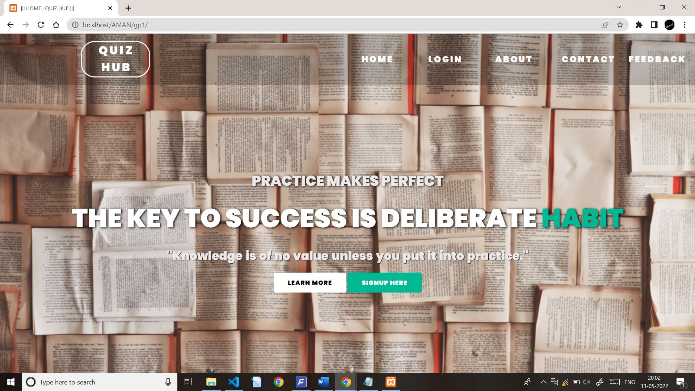

LOGIN FORM:

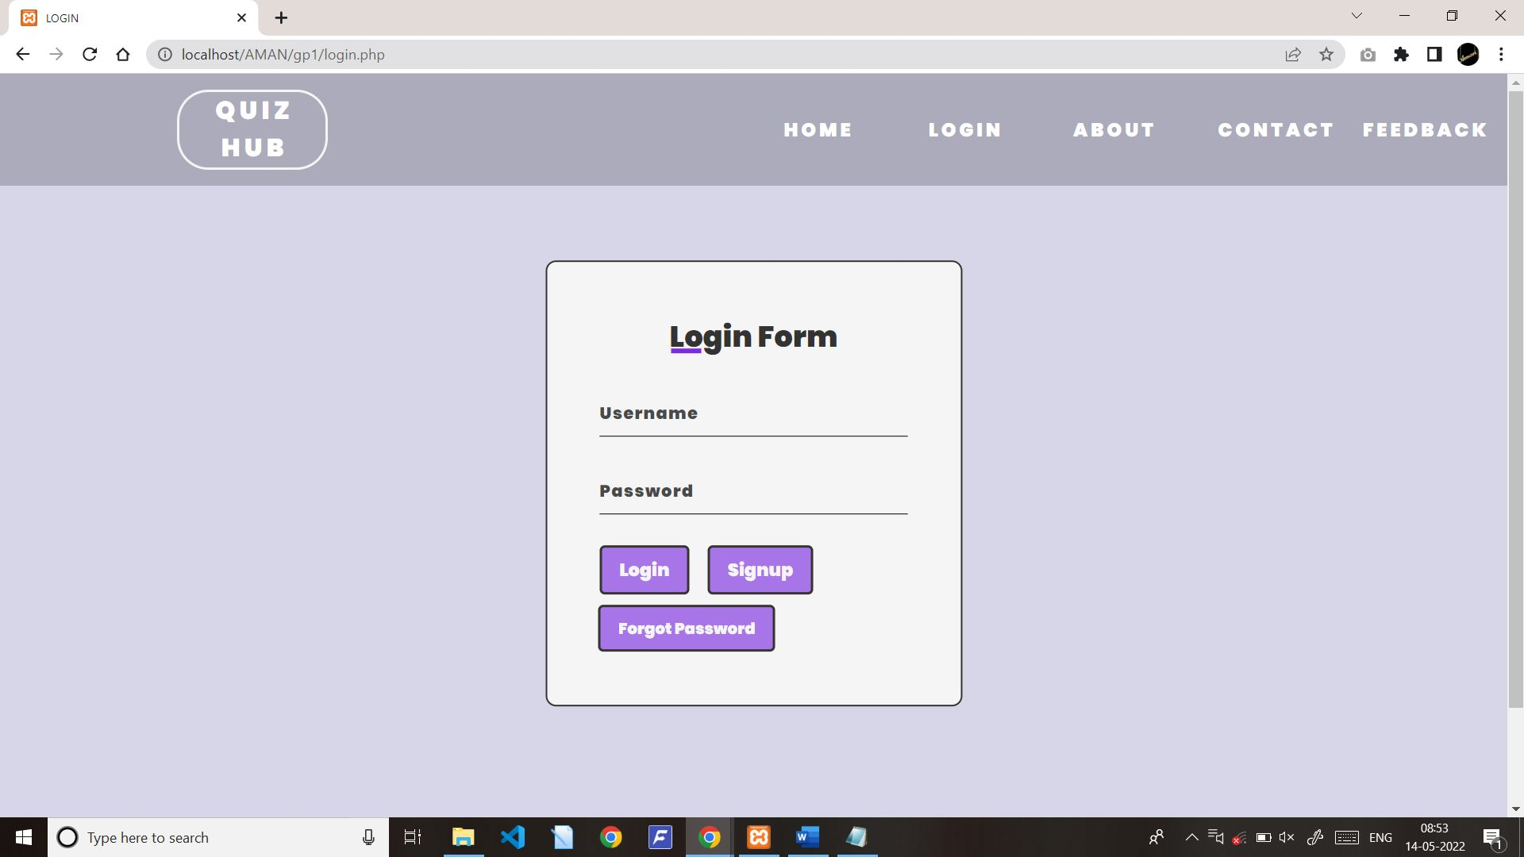

FORGET PASSWORD PAGE:

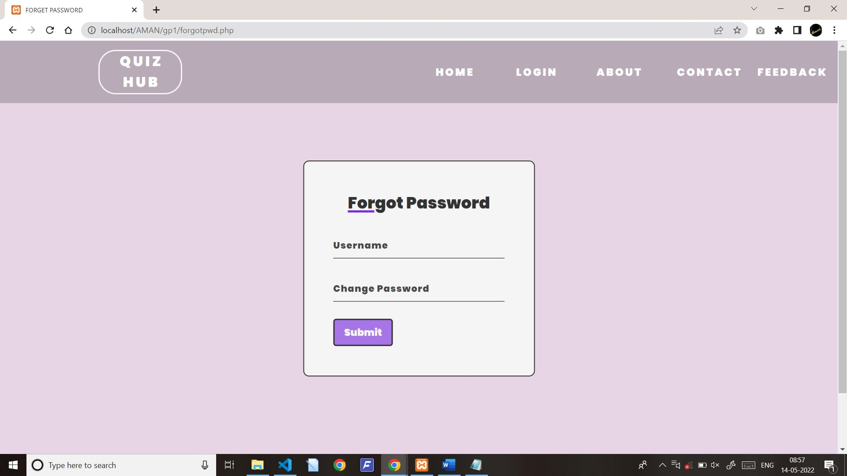

REGISTRATION FORM:

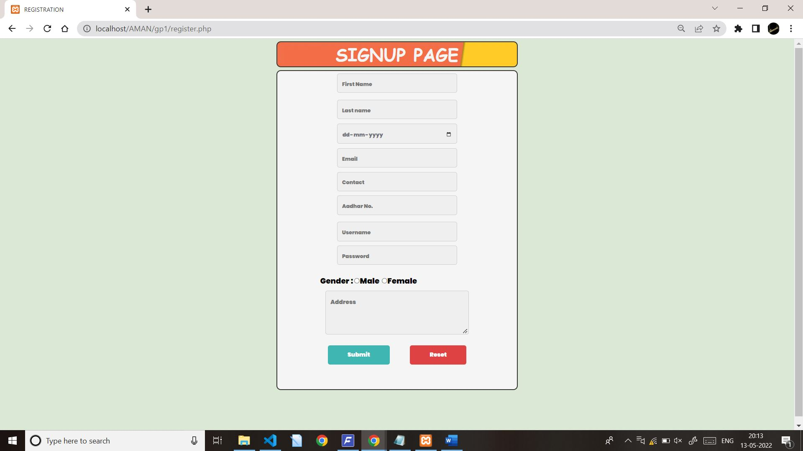

USERPAGE:

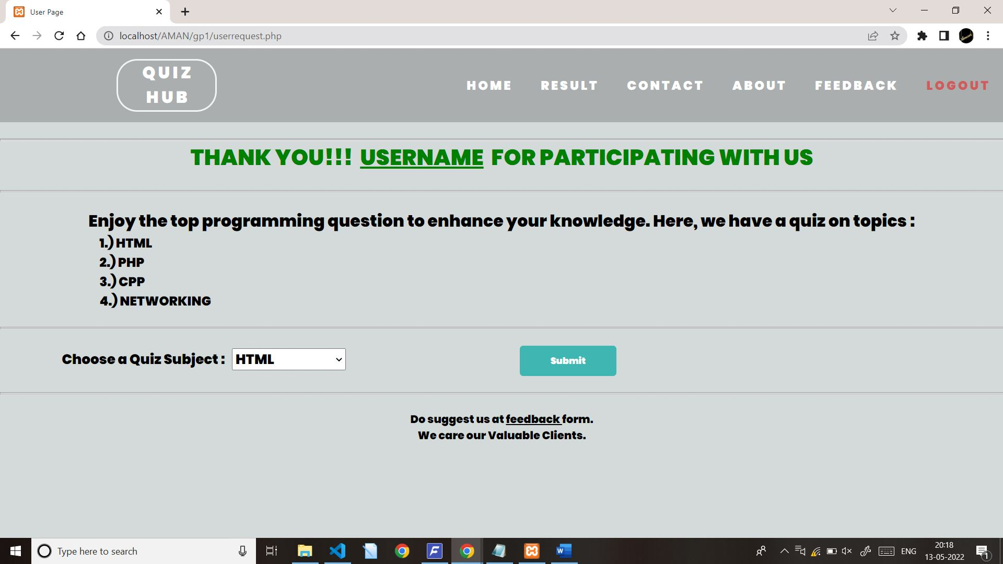

CONTACT PAGE:

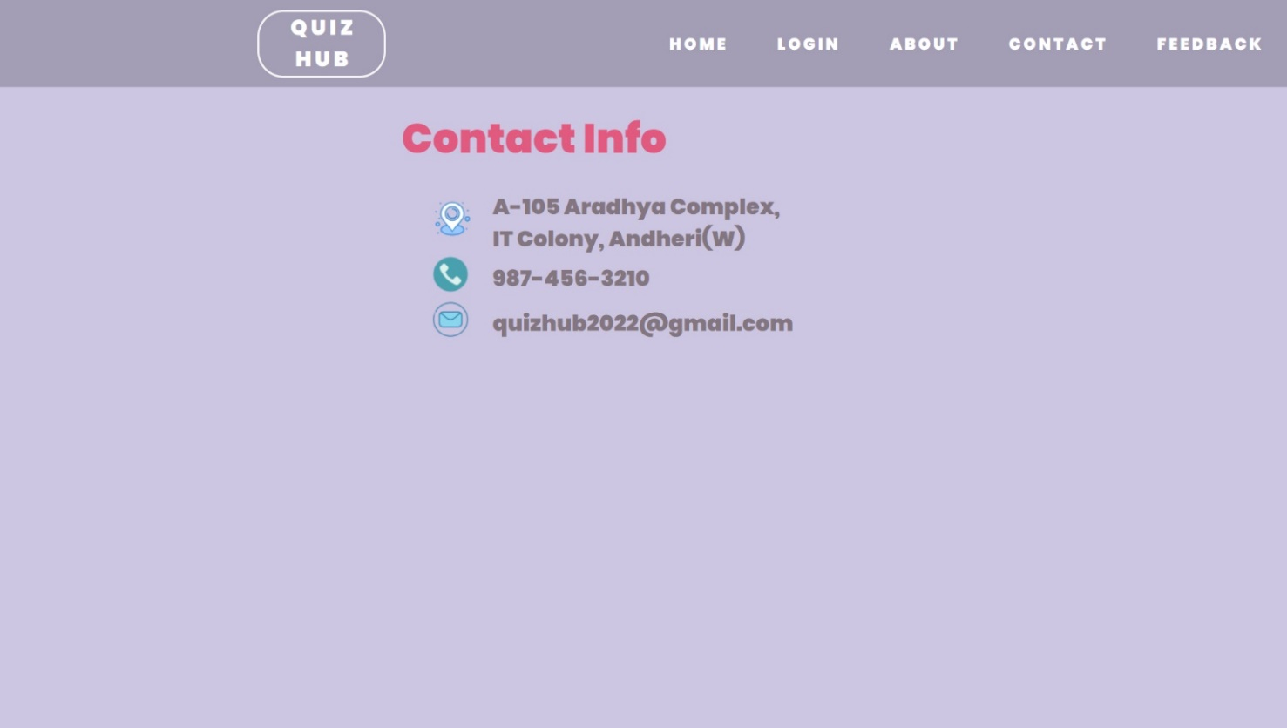

QUIZ 1: HTML FORM

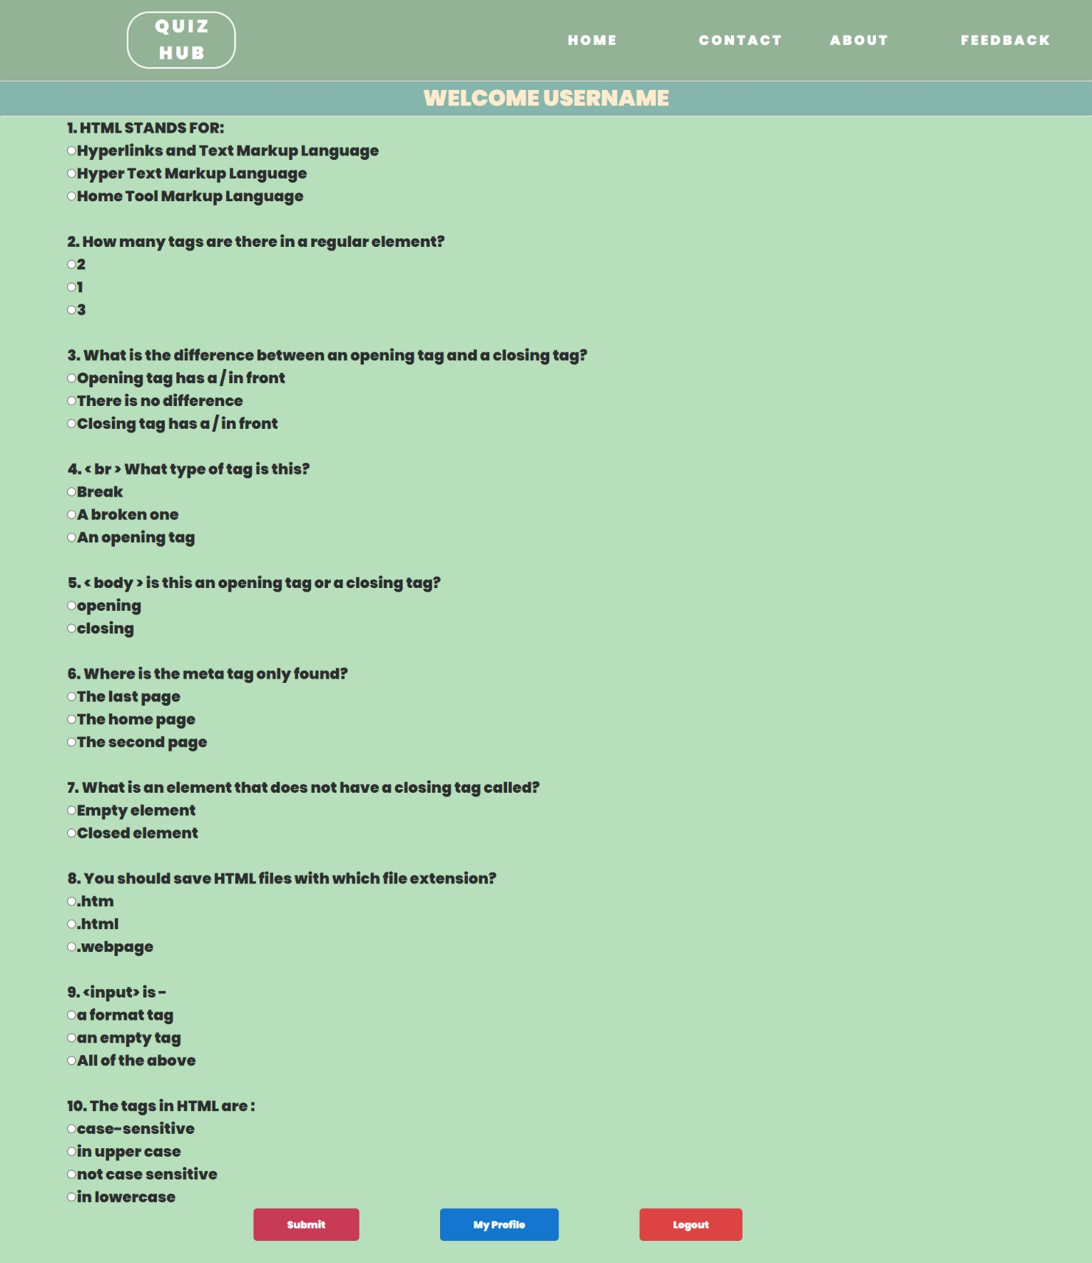

QUIZ 2: PHP FORM

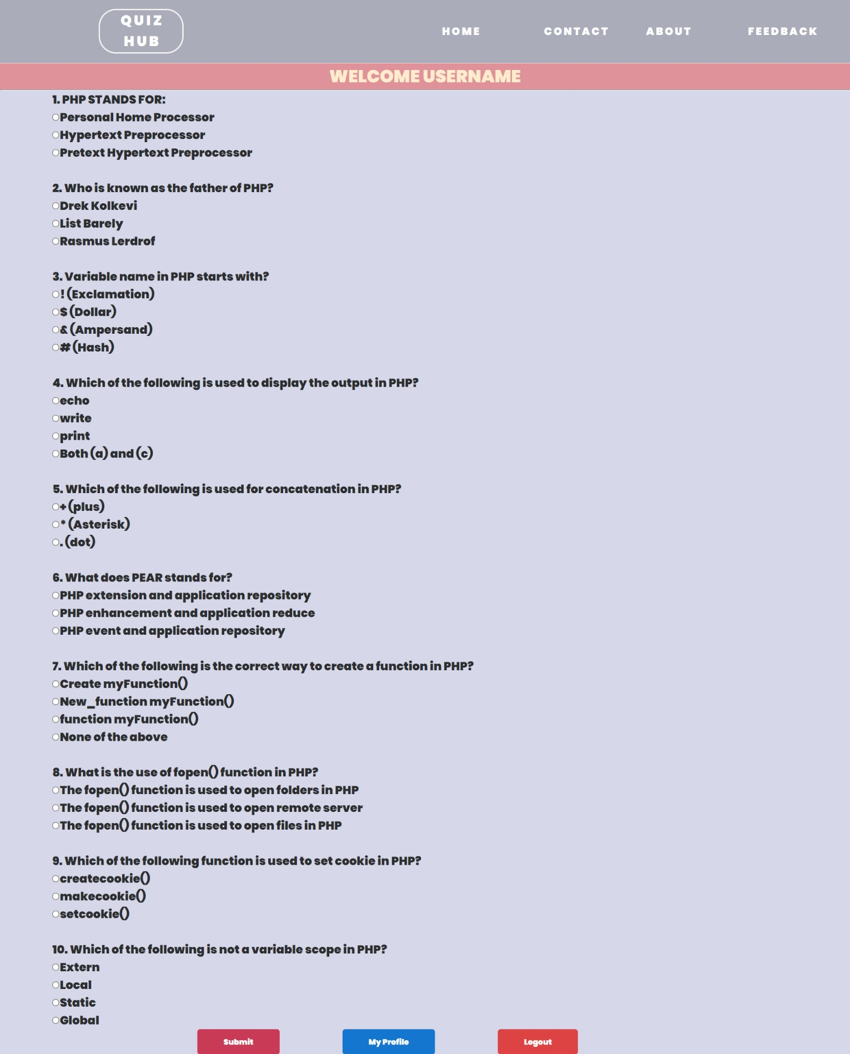

QUIZ 3: CPP FORM

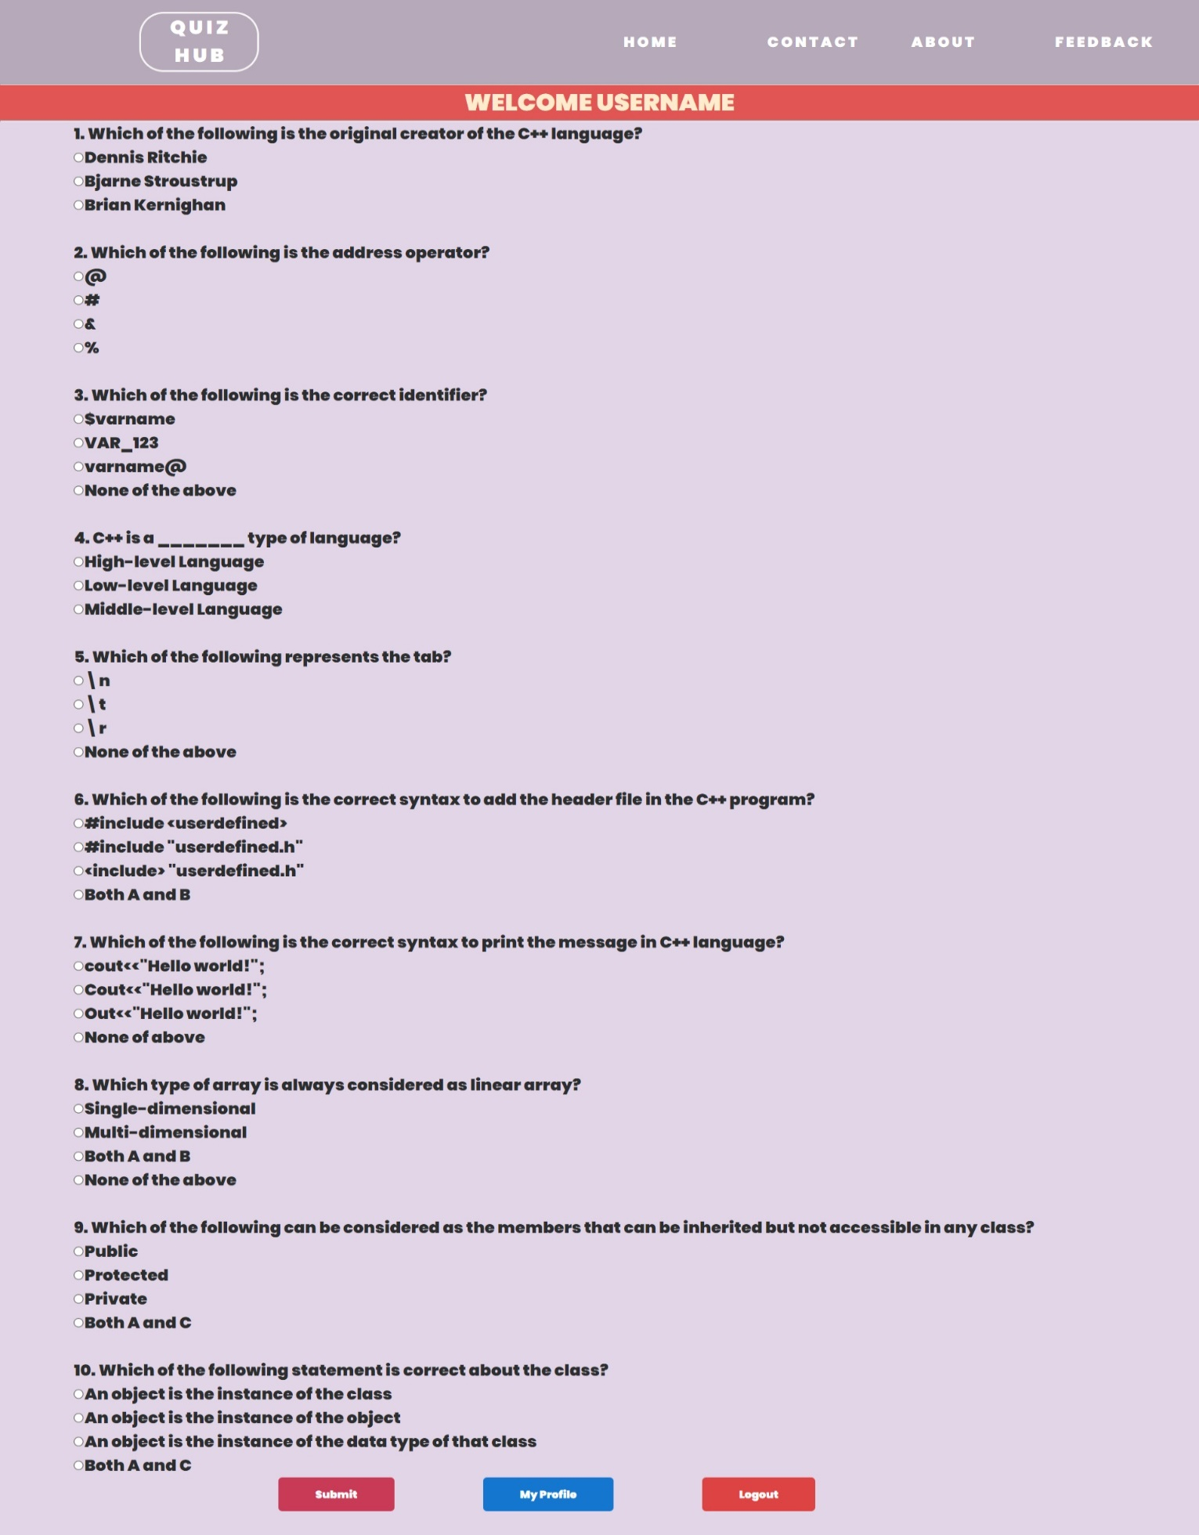

QUIZ 4: NETWORKING FORM

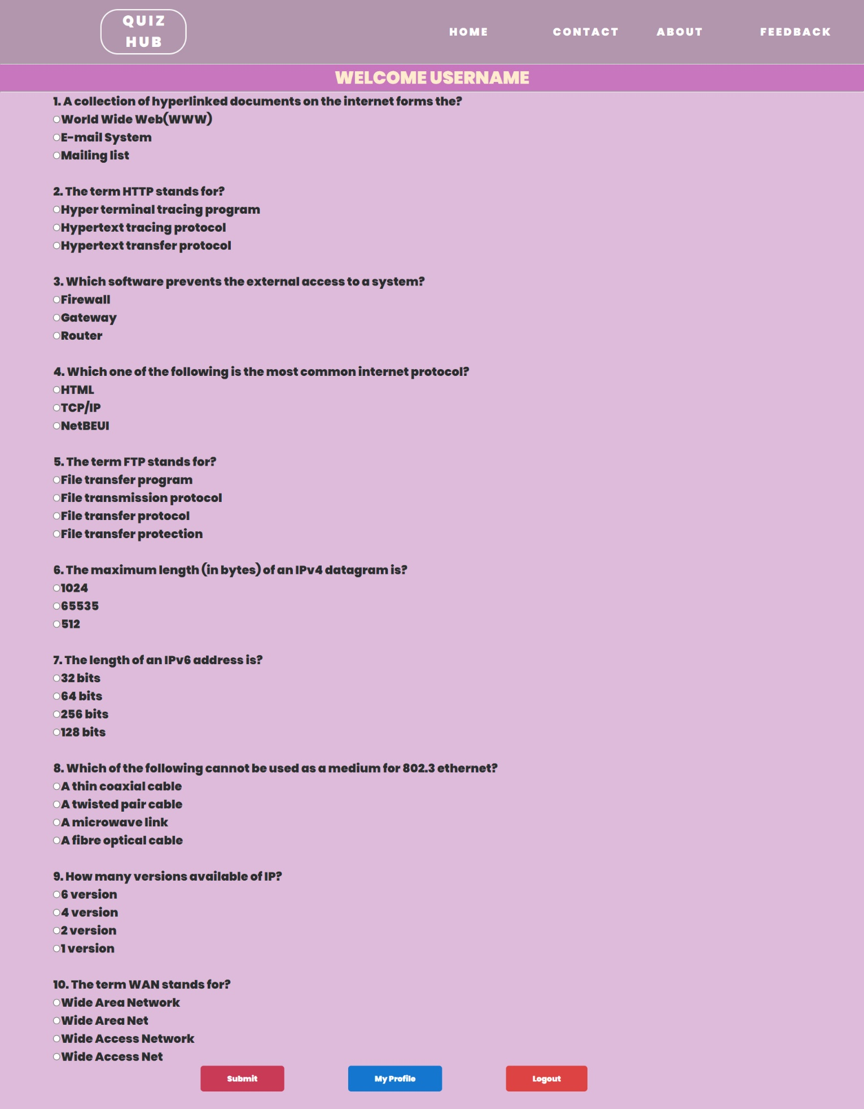

RESULT PAGE:

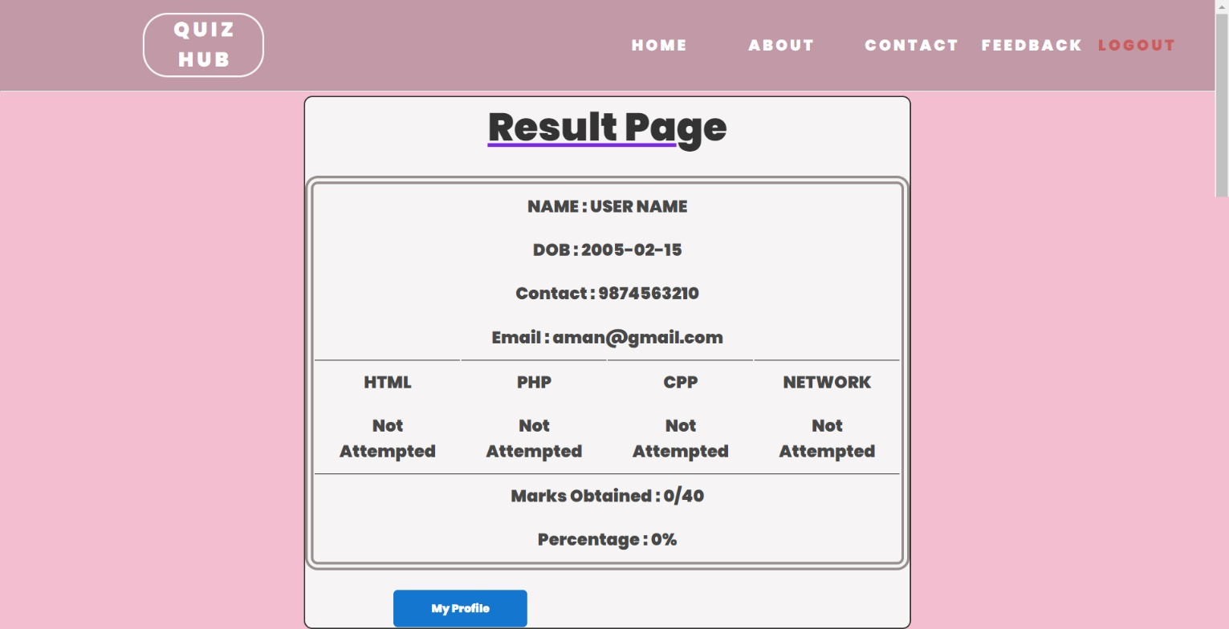

LOGOUT PAGE:

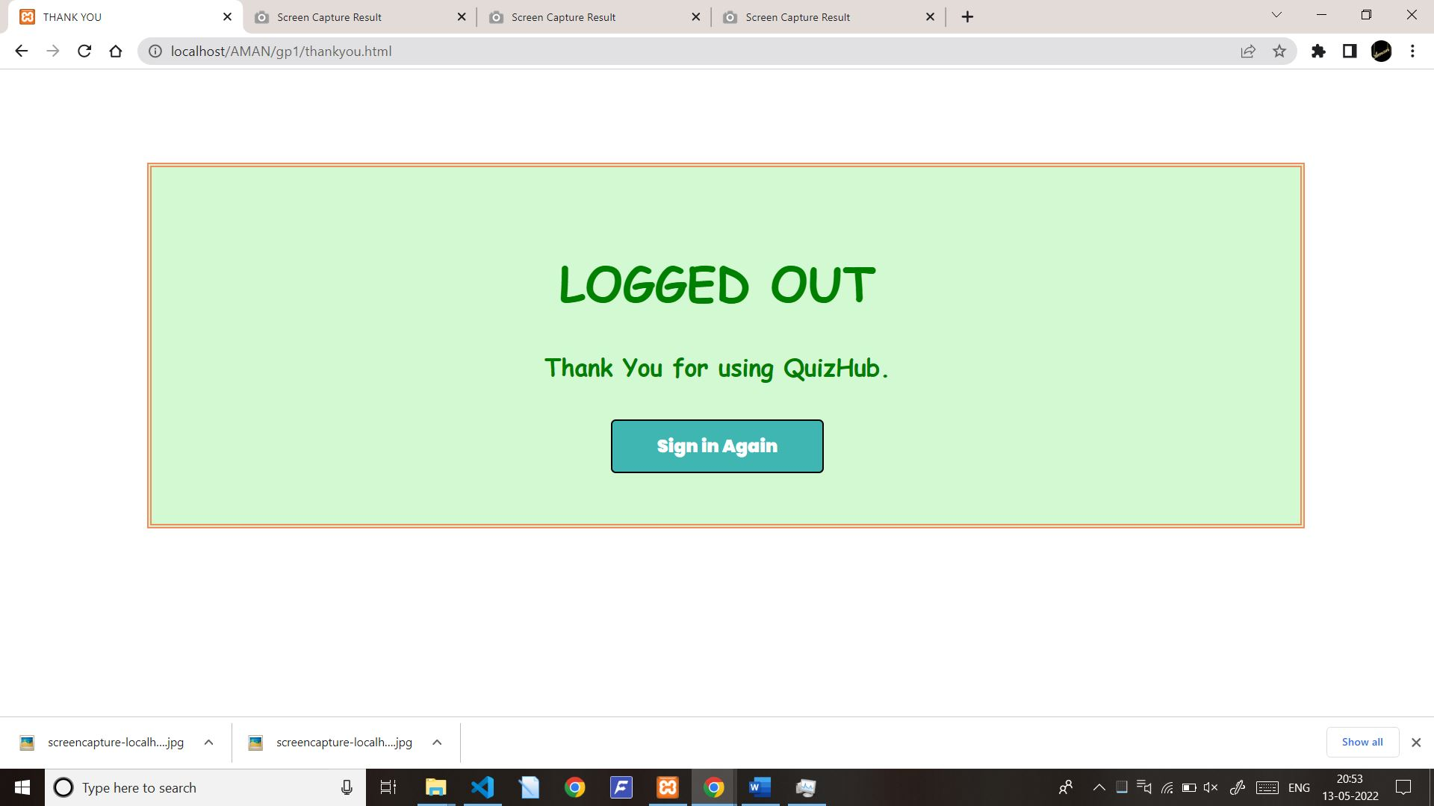

FEEDBACK FORM :

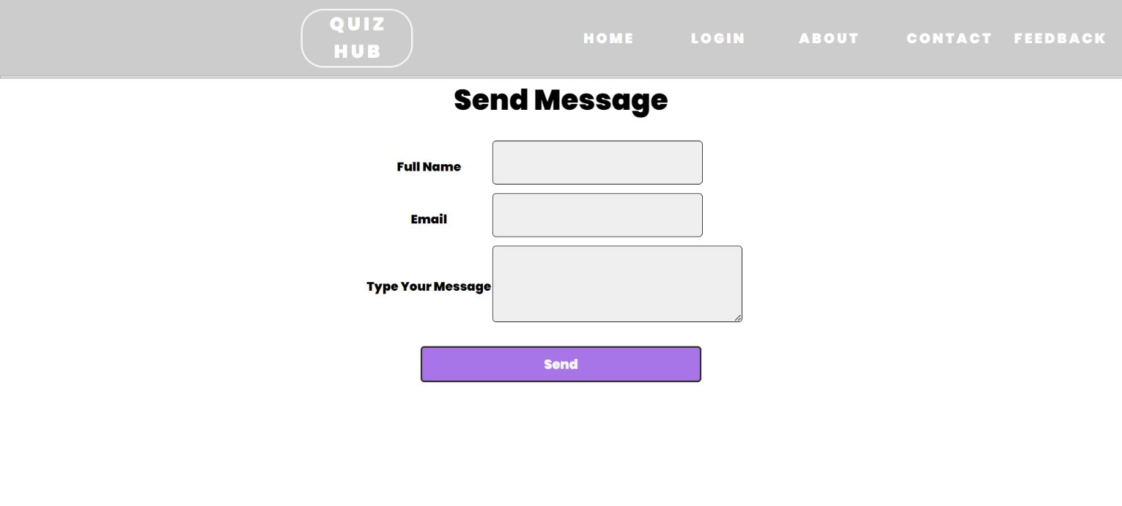

ABOUT PAGE:

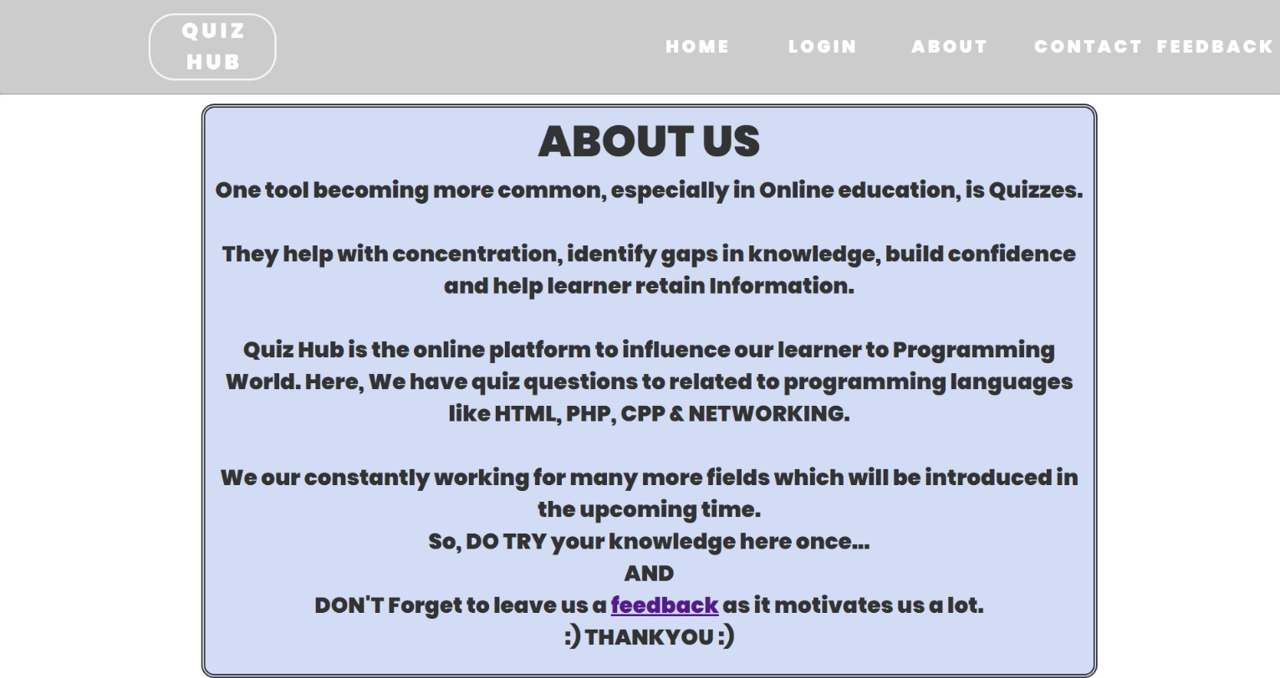

**7. REPORTS**

REGISTRATION PAGE:

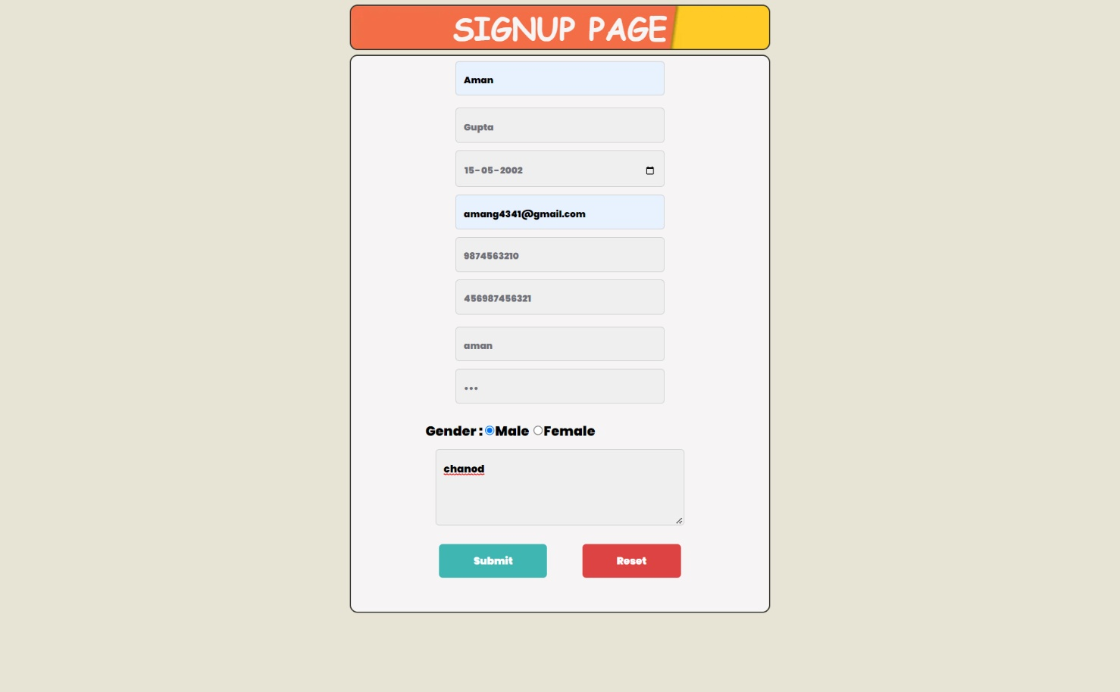

DATA REPORT:

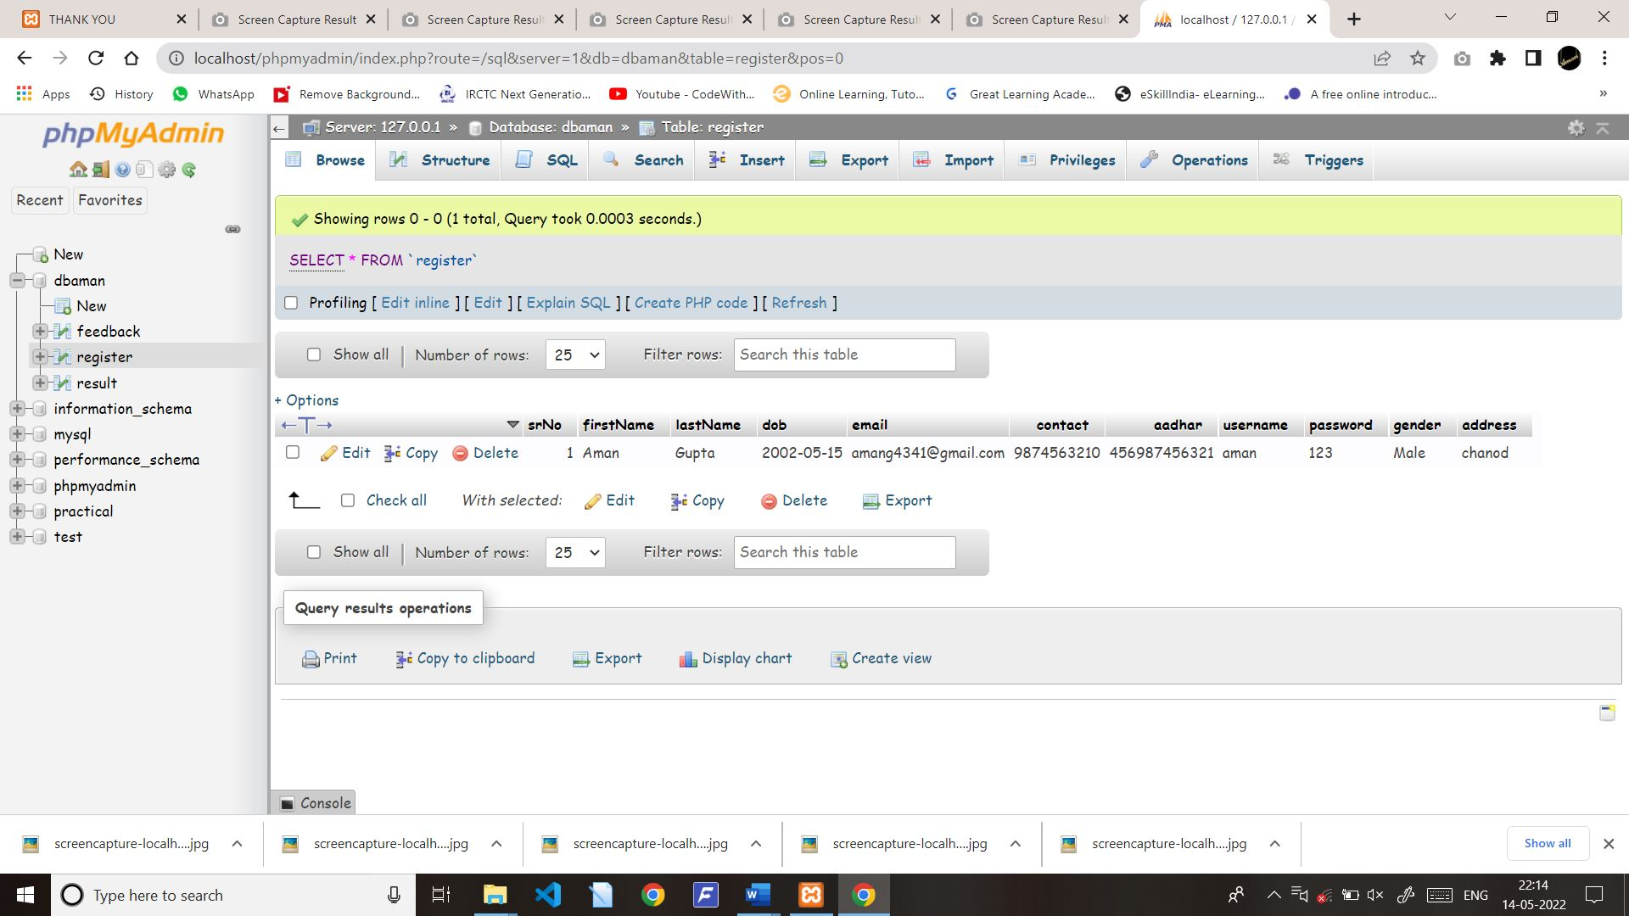

QUIZ : HTML FORM

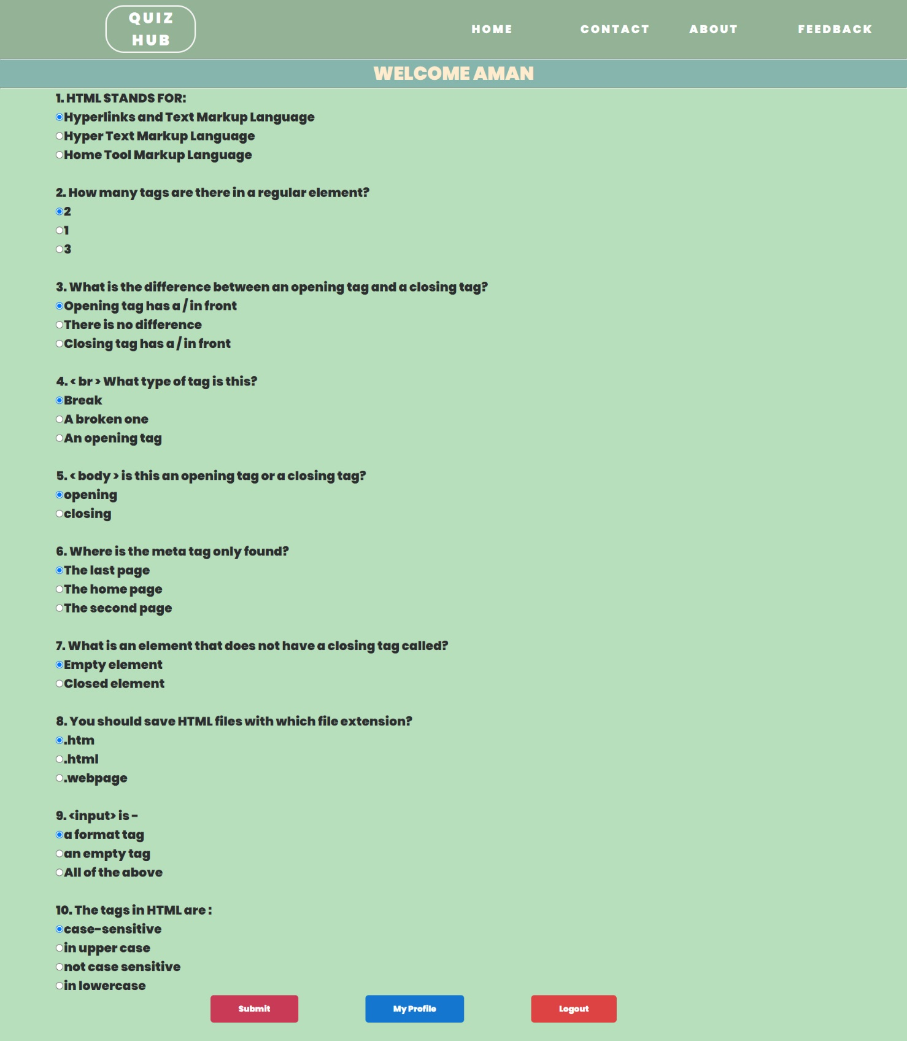

DATA REPORTS:

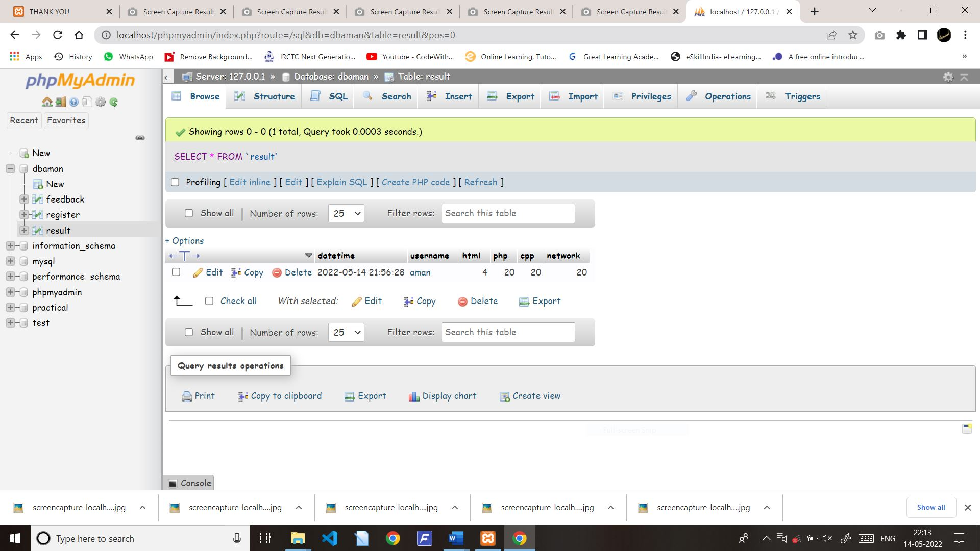

RESULT PAGE:

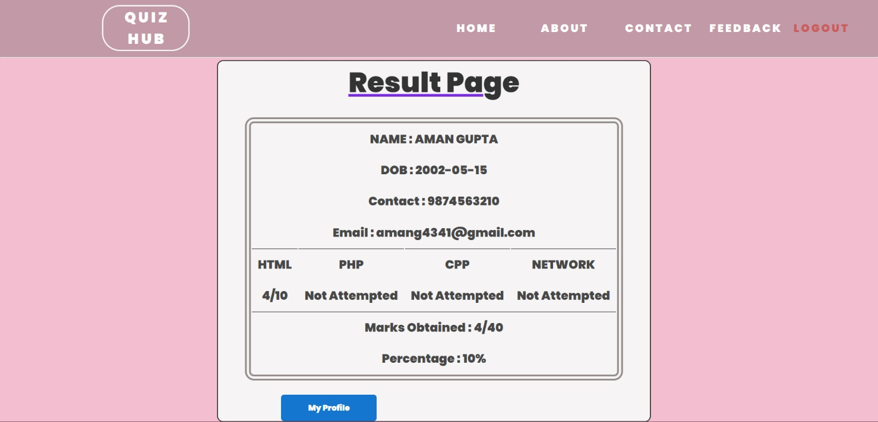

FEEDBACK:

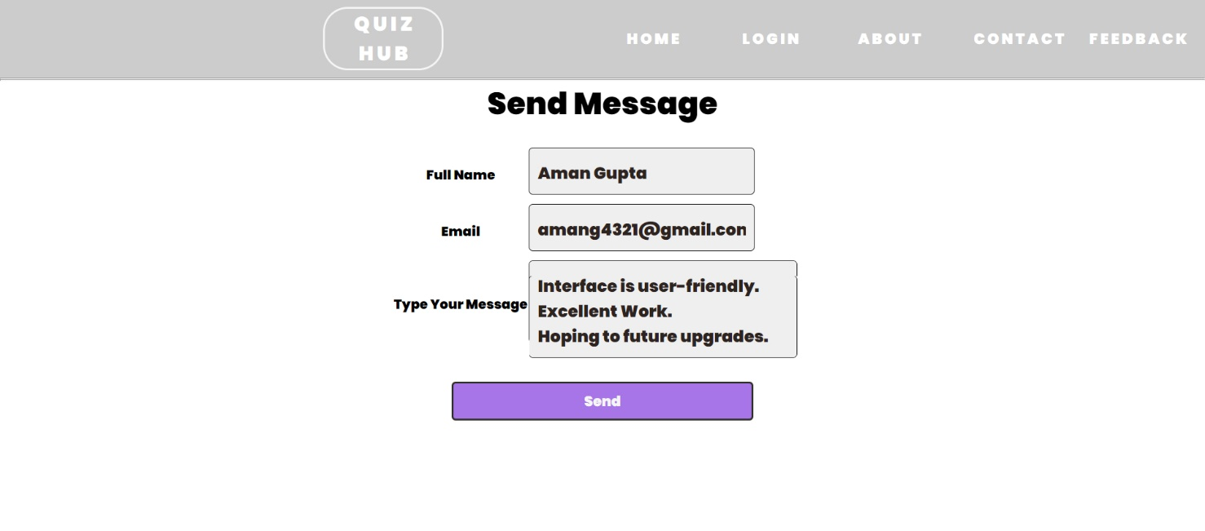

DATA FEEDBACK:

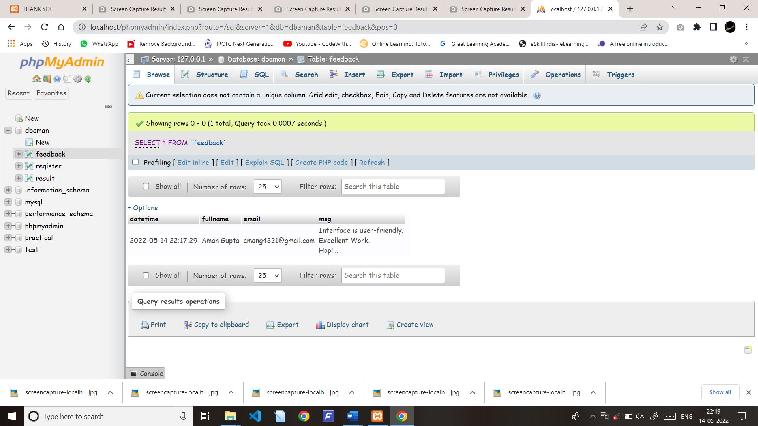

**8. ADVANTAGES AND**

**LIMITATIONS**

ADVANTAGES :

The system successfully meets the following requirements:

* Stores and maintains user information.
* Forgotten passwords can be recovered through valid processes
* Can update user information.
* Scores of each will displayed in result page.
* User could feeds us in feedback form.

VALIDATION OF DATA:

* Invalid data input is prompted using proper message boxes.
* The data is not stored until it passes the valid data.
* Incorrect username and passwords are not accessed.
* Quiz page is not submitted unless all questions are attempted.

LIMITATIONS :

* Copyright violation.
* Its client side project.
* No admin page.
* Limited subjects included for quiz.
* Limited questions.
* It requires further development as per the human requirements, specially in the field of server side.

**9. FUTURE ENHANCEMENT**

The program is user-friendly. Proper used of well reserved words gives user ease of understanding. The future holds a lot to offer to the development and refinement of this project. As proper documentation exists the whole system flow is traceable. Some likely enhancements could be added in the future to enhance the capability of this program.

We may conclude that this Web program created will definitely find a good market in the E-Learning World.

**10. BIBLIOGRAPHY**

**WEB REFERENCE :**

* [www.google.com](https://www.google.com)
* [www.youtube.com](https://www.youtube.com)
* [www.stackoverflow.com](https://www.stackoverflow.com)
* [www.javatpoint.com](https://www.javatpoint.com)
* [www.w3schools.com](https://www.w3schools.com)